Uploading a Video to YouTube

YouTube is a website that allows you to upload videos that can be shared publicly or privately. Whether you’re
announcing a new course or want to demonstrate instructional learning, this website is useful for distributing information via video at no cost. Once uploaded, videos can be shared through links or embedded into webpages. Follow the instructions in this job aid and you should be able to successfully upload a video to YouTube.

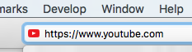
- After creating a video and saving it, open a web browser; in the web bar, type https://www.youtube.com and press Enter.
1
- In the top right corner click the blue Sign In button
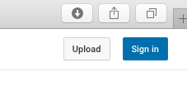
2
- You will need a YouTube account to upload your video. Please see the How to Set Up a YouTube Account job aid to assist you if needed. Enter your Username and Password and click the Sign In button. You can also choose to sign in with your Google account, click the Google button to sign in using Google.
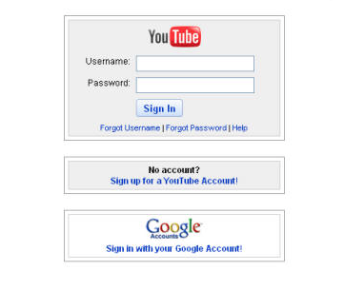
3
3
- At the top right corner click the Upload button.
4

- The Select Files To Upload page will appear.
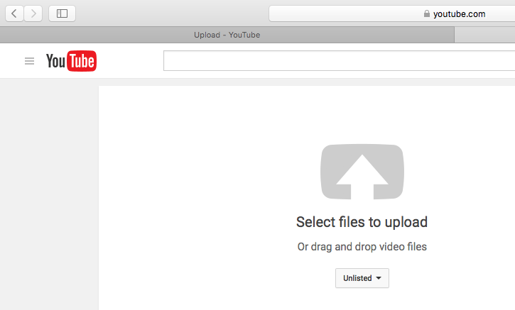
5
- Before uploading your video, select your privacy level. Use the red box below as a guide.
- Click the downward facing arrow on the dropdown menu labeled Unlisted. Click on who you want to be able to view your video.
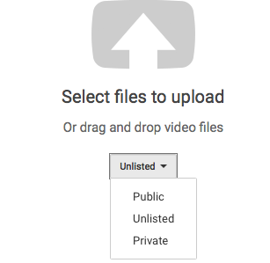
Choose Public if you:
- want anyone with Internet access to view your video.
- want your video to appear in any of YouTube's public spaces such as search results, your channel, or the browse page.
- do not want any limitations on number of users or who view your video.

Choose Unlisted if you:
- do not want your video to appear in any of YouTube's public spaces such as search results, your channel, or the browse page.
- only want people who have the video link to view it.
- do not want any limitations on number of users.
- want people with or without a YouTube account to view your video.

Choose Private if you:
- do not want your video to appear on your channel, in search results, or in playlists etc.
- want 50 or less other users with YouTube accounts to view the video.
- want only viewers you invite to view the video.
7
6

- You are now ready to upload your video. Click the Select Files To Upload arrow icon in the center of the screen.
8
- Select the video file from your computer by clicking on the file you want to upload (this screen shot is from a Mac your screen might look a bit different). Click the Choose button in the lower right corner (may be titled Ok depending on your computer).
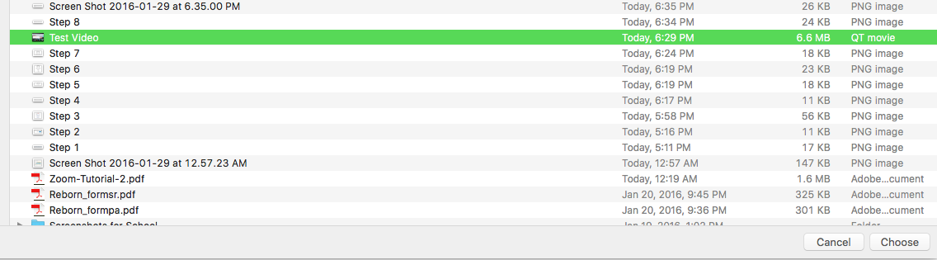
9
- Your video will begin to upload.
:
If you chose Private or Unlisted views, a blue rectangular button labeled Done will appear in the top right portion of your screen: have:

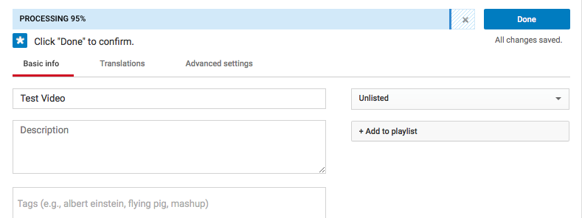
10

If you chose Public views a blue rectangular button labeled Publish will appear at the top right of your screen:
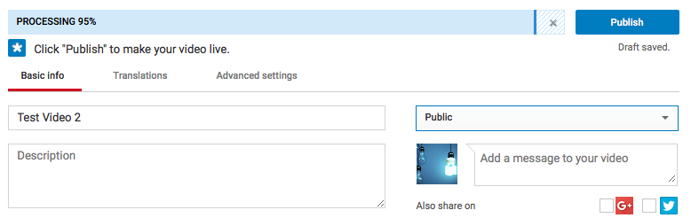
10

- While the video is uploading, you can add a description of the video by clicking on the Description box and entering your description.
- You can also add tags, which are key words people would use to search for your video by clicking on the Tags box and entering your text.
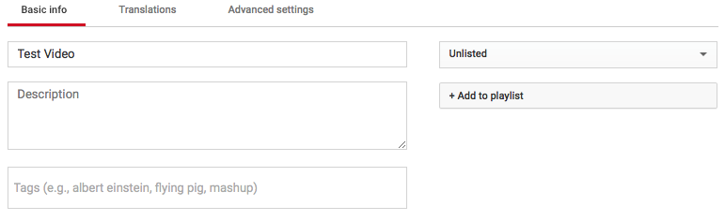
12
11
- Click the blue Done or Publish button in the right top corner of your screen.
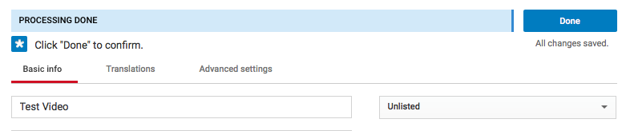
13
13

- After you click the Done or Publish button, the screen below will appear. You can share your video through any of the Social Media Options by clicking on them. The Social Media Options are the small tiles with social media icons on them, hover over each tile using your mouse to view the full names.
- Another option is to share your video by copying the website link. Highlight the link with your mouse, right click your mouse, select Copy and right click Paste where you want the link to show up. The link can be pasted into, emails, text of webpages or on social media sites. See the Fifteen Ways to Share YouTube Videos job aid for more options.
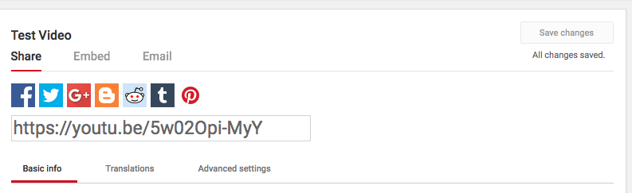
15
14
- You can add more videos by clicking the Add More Videos button in the bottom right corner of your screen and follow steps 11 -15 above.
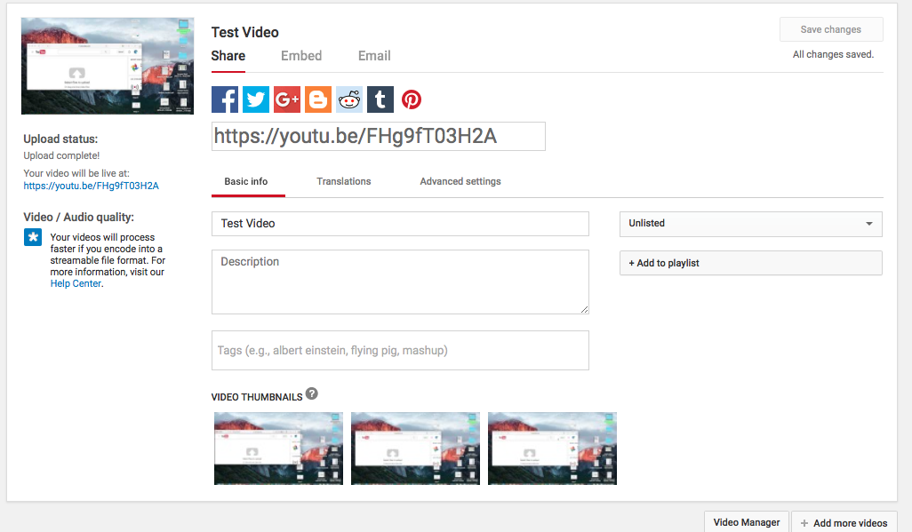
16
Congratulations! You have uploaded a video to YouTube! Be sure to check out all of the other YouTube job aids housed here on SharePoint.

